Supplemental information

Limitations of the photostimulation technique
Although the technique of photostimulation via uncaging of glutamate has been well established over the last two decades (Callaway and Katz 1993), there are certain constraints and caveats of this technique. In the following sections, we provide a detailed discussion of some of these constraints and caveats which are crucial for interpreting the resulting data.

Di-synaptic driving of neurons
Our approach of functional mapping with the help of laser uncaging of glutamate is based on the assumption that cells (i.e., somata of cells) located at the uncaging location fire action potentials, which, via intact axonal projections, cause postsynaptic responses in the cell whose membrane potential is being measured (target cell). In principle, however, postsynaptic responses could also be elicited in a di-synaptic fashion. If a group of neurons at the uncaging location, which are not directly connected to the target cell, fire action potentials, and their projections converge on another neuron (the ‘intermediate cell’) somewhere in the slice that projects onto the target cell, a sufficient stimulation of the first population could drive the intermediate neuron to fire an action potential, thus eliciting a postsynaptic response. In that case, the functional mapping approach would generate misleading results, because the location of the intermediate neuron would not be revealed. Even though this possibility exists, several considerations make it unlikely that di-synaptic driving of neurons does occur in our experiments: (1) If such strongly convergent projections would exist in our preparation, we should (at least occasionally) observe very strong depolarizing events also in our postsynaptic cells. However, we never observed responses sufficient to generate APs in the recorded postsynaptic neuron upon stimulation of positions away from the perisomatic area of the neuron (both in excitation profile and in mapping experiments, cf. Fig. S4A, B). (2) Our calibration experiments ensure that there is no overstimulation of the tissue/neurons: Since neurons in different layers can have different input resistance or resting membrane potentials (Fig. S3A, B), making them more or less excitable, we adjusted the stimulation strength for each layer to be minimally efficient in driving neurons to generate APs (mostly 1-2 APs, cf. Fig. 1E, F). (3) Adding the NMDA-receptor blocker D-AP5 generally reduces the excitability of neurons, thereby making di-synaptic driving even more unlikely. (4) Considering the overall hyperpolarized membrane potential of neurons in a slice preparation (~ -65 to -85mV, cf. Fig. S3B), the distance to AP-threshold in a given neuron will be quite high (~25-40mV), whereas the synaptic drive generated even by several activated neurons will be rather low (at an average EPSP-amplitude of ~0.5mV). Finally, several other groups employing essentially the same method have also reported the absence of di-synaptic driving under properly calibrated experimental conditions (Katz and Dalva 1994; Dantzker and Callaway 2000; Schubert et al. 2001; Shepherd et al. 2005; Weiler et al. 2008). Therefore, we conclude that it is unlikely that di-synaptic driving occurred in our experiments.

Driving of neurons via activation of distal dendritic regions
Although it is, in principle, possible to evoke AP-firing by uncaging of glutamate on distal dendrites by increasing the stimulation strength several-fold, we did not observe AP-generation upon strong stimulation of the distal dendritic tuft (Fig. S4). Furthermore, these high stimulation intensities were never reached in our experiments. This is mainly due to the fact that, especially for large pyramidal neurons, the distal dendrite is electrotonically separated from the perisomatic region where AP-generation occurs. As a consequence, all membrane potential deflections, whether induced by synaptic input or via glutamate uncaging, are severely attenuated along the apical dendrite due to the passive membrane properties of the cells (Rall 1967).

Truncation of axonal projections
The truncation of axons in slice preparations is a known fact (Stepanyants et al. 2009). However, long axonal processes can be preserved if the slicing angle is optimized such that apical dendrites are oriented parallel to the cortical surface, as is the case in our experiments. The experimental observation of an increase in average EPSP-latency with distance, which reflects the increase in axonal delay (cf. Fig. S6B), also suggests that monosynaptic, long-range projections may be preserved. At the same time, long-range projections will suffer more from truncation than local projections (Stepanyants et al. 2009), since they are more likely to be cut, resulting in an underestimation of long-range inputs in our experiments. Thus, our estimation of horizontal connectivity should be even biased towards more local projections, representing circumstantial evidence for our hypothesis that long-range horizontal projections constitute a large part of the synaptic inputs to L5B pyramids.

Estimation of horizontal connectivity
The decay constant of connection probability is based on relative values of responding versus non-responding locations in the mapping grid, since we sample potentially connected regions (i.e. pixels in the map) on a certain spatial scale. At the same time, the estimation of relative connectivity along the horizontal axis in our experiments is especially problematic in close proximity to the postsynaptic neuron, since it will also be depolarized by the released glutamate. These direct responses we observed were usually rather large (~5-15mV) compared to the depolarization induced by activated synapses (mean EPSP-amplitude: ~0.5mV) and became progressively smaller with increasing distance from the dendritic tree of the neuron (giving rise to mixed responses, cf. Fig. 2C). This means that synaptic depolarizations are likely to be masked by direct responses when mapping locations close to the postsynaptic neuron. Hence, we decided to only include sites with horizontal distances larger than 300µm from the somato-dendritic axis of the postsynaptic neuron for fitting the decay of horizontal connectivity, since 300µm is the approximate radial extent of the basal and distal dendritic tree of L5B-PNs (Romand et al. 2011). For single experiments, direct responses could sometimes be observed for distances larger than 300µm. For such cases, we decided to count these locations as having equal chances of being connected or not connected (0.5, ambiguous responses). The overall number of these instances was very low, however (cf. Fig. 2F green fraction, 2-7% of all connected locations).

identifying presynaptically generated responses
Usually, membrane potential deflections generated by presynaptic vesicle release are identified according to differences in their time course (fast, asymmetrical, late onset) compared to responses induced by direct uncaging on the postsynaptic dendrite (slow, symmetrical, early onset) or in post-hoc control experiments using TTX (Tetrodotoxin) to block AP-generation in presynaptic neurons. The latter were omitted in this study due to the time consuming stimulation protocols, since we had established in earlier studies (Boucsein et al. 2005, 2011; Nawrot et al. 2009) that a careful inspection of the time course is sufficient to classify responses. Although other groups have reported on data acquired from locations close to the postsynaptic neuron (e.g. Schubert et al. 2001), we specifically avoided the analysis of local inputs for two reasons: Firstly, photostimulation close to the postsynaptic neuron will result in variable amounts of direct depolarization of the postsynaptic dendrites, as already mentioned in Section 1.4. Thus, there is a continuous decrease in the amount of direct depolarization, which is increasingly difficult to disambiguate from slower EPSPs. Secondly, due to the short-range nature and high connection probabilities of inhibitory projections (Fino and Yuste 2011), their activation by photostimulation close to the soma (0-300µm) could lead to a contamination of EPSPs with coincident IPSPs, or shunting inhibition. These factors would introduce an uncontrollable bias in the estimation of excitatory EPSP amplitudes from locations close to the postsynaptic neuron. Therefore, we decided to rather compare our data to values extracted from studies using techniques that allow for a reliable quantification of synaptic strength and local connection probability (i.e. paired recordings). Along these lines it has to be stated that the strong filtering and attenuation effects of the dendritic tree in these large neurons lead to a somatocentric view of functional connectivity as well as synapse properties, since electrotonically remote synaptic inputs are probably missed in somatic recordings.

Summary
It needs to be stated that, even with our careful calibration experiments, the control of presynaptic cell firing and the spatial resolution of photostimulation remains limited. Our data shows that D-AP5 leads to a reduction of the numbers of action potentials per stimulation (Fig. 1F), although we cannot confirm the statement of Matsuzaki et al. (2008) of achieving single APs in almost 100% of the cases, since we still could observe bursts of APs. This might be predominantly due to the different techniques of one-photon versus 2-photon uncaging between the two studies. Nevertheless, we observed a substantial increase in spatial resolution under D-AP5, especially for L6 pyramidal neurons (Fig. 1D). This might be due to the fact that L6 neurons are very excitable, as is reflected in their high input resistance compared to other cells (Fig. S3A). Furthermore, under D-AP5, we observed an elimination of the accumulation of excitability with consecutive trials (Fig. 1G, S3D). One hypothesis why responsiveness could increase over trials is that the repeated activation of NMDA-receptors leads to an accumulation of glutamate effectiveness in driving the presynaptic neurons, thereby increasing their excitability with consecutive stimulation. It should be noted that the minimally efficient stimulation strength even within one layer can vary (cf. Fig. 1E). Therefore, when using mean stimulation strengths during the functional mapping, some neurons will never fire action potentials, whereas others may produce bursts. Thus, the efficient spatial resolution R for a given cell type might vary, thereby producing false positives in adjacent pixels during functional mapping. Although it is impossible to adjust the stimulation strength perfectly for every single stimulation site during a functional mapping, we tried to minimize these problems by adapting the stimulation strength for each layer as well as by choosing a spacing of 100µm for the mapping grid, well above the measured values of R (mean: 44µm/60µm for D-AP5/No D-AP5, respectively). Most other studies simply used fixed stimulation strengths (Katz and Dalva 1994; Dantzker and Callaway 2000; Schubert et al. 2001; Briggs and Callaway 2005; Shepherd et al. 2005), thereby either biasing the results for the functional connectivity towards more easily excitable neurons or, by over-stimulating the tissue, decreasing the spatial resolution of their mapping and producing more false positives. In some functional mapping experiments, the stimulation strength was adjusted by increasing the values for the PD by 1-2ms to ensure presynaptic action potential generation. In a subset of the control experiments, we tested the impact of this slight increase of stimulation strength and found no decrease in spatial resolution while the generation of APs was facilitated (Fig. S3E).

Neuronal network model
The neurons in the network were modeled as leaky integrate-and-fire neurons, with the sub-threshold dynamics of the membrane potential in neuron i described by:

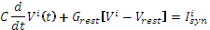 (1)

where is the total synaptic input current into neuron , and C = 250pF, G_{rest} = 16.7nS reflect the passive electrical properties of its membrane at rest (V_{rest} = -70mV). When the membrane potential reached a fixed spike threshold V_{thresh} = -55mV (15 mV above rest), a spike was emitted, the membrane potential was reset to its resting value, and synaptic integration was halted for 2ms, mimicking the refractory period in real neurons. We simulated a network of 50,000 neurons, with 40,000 excitatory and 10,000 inhibitory neurons. The excitatory neurons were arranged on a Cartesian grid of 200 x 200, the inhibitory neurons on a grid of 100 x 100. Both grids represented the same cortical space of 2x2mm². To avoid boundary effects, the network was folded as a torus. The recurrent network was sparsely connected (K_{excexc} = 2,500; K_{excinh} = 500; K_{inhexc} = 2,500; K_{inhinh} = 500). The connection probability for both excitatory and inhibitory neurons changed as a function of distances (Fig. 6A). Within a distance of 0.1, which roughly corresponds to a distance of 200µm in a biological cortical network, the presynaptic neurons to a given postsynaptic neuron were uniformly distributed. However, a neuron received only 10% (250) connections in this small area. Connection probability decreased exponentially with a space constant of net_{space}. This type of connectivity profile was based on our experimental findings (cf. Fig. 2). In the simulation, net_{space} was a free parameter. While increasing net_{space}, we did not change the local distance independent connectivity within a radius of 0.1. When we systematically varied net_{space}, we kept the number of inputs to a neuron constant because we were interested in studying the effects of excitatory connectivity space constants. Connection probability for the inhibitory neurons also varied in the same manner as for the excitatory neurons. However, the space constant for the inhibitory connection was kept constant at a value of net_{inhspace} = 0.1, mimicking the experimental observation that inhibitory connectivity space constants are smaller or comparable to excitatory connectivity space constants (Kätzel et al. 2011). Synaptic input was modeled by transient conductance changes, using α-functions

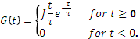 (2)

Synaptic conductance transients were chosen to have a uniform rise time of τ = 0.33ms. That is, here we considered AMPA and GABA-A type fast synapses. We refer to the peak amplitude 'J' of the conductance transient at t = τ as the ‘strength’ of the synapse. Generally, excitatory and inhibitory synapses had different strengths J_{exc} and J_{inh}. Assuming fixed synaptic couplings, the total excitatory conductance in neuron was given by

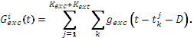 (3)

The outer sum runs over all excitatory synapses onto this particular neuron, the inner sum runs over the sequence of spikes arriving at a particular synapse. The delay D increased from 1ms to 3ms as a function of distance between the neurons. Similarly, the total inhibitory conductance in neuron was given by

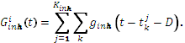 (4)

Thus, the total synaptic current into neuron was

(5)

with V_{exc} = 0mV and V_{inh} = -80mV denoting the reversal potentials of the excitatory and the inhibitory synaptic currents, respectively. The ratio

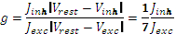 (6)

that approximately corresponds to the ratio of peak amplitudes of IPSPs and EPSPs at rest, was used to parameterize the relative strength of inhibition. On average, every neuron experienced the same amount of conductance change. However, as the neurons had different passive properties, single PSPs were slightly different. The amplitude of EPSPs and IPSPs was chosen from a uniform distribution (U[0.1, 0.2]). The mean unitary EPSP and IPSP amplitude was 0.15mV at rest, in the absence of synaptic background activity. We systematically changed the ratio g by changing the amplitude of the IPSPs to obtain different activity states of the network activity.
Background input: All neurons received Poisson type external excitatory inputs during the entire time of simulation. This input mimics the long-range connections from other cortical areas or sub-cortical structures which are necessary in our simulations to drive the neurons to spiking. The rate of external inputs ν_{ext} was a free parameter in our simulations.

Supplemental References
Boucsein C, Nawrot M, Rotter S, Aertsen A, Heck D. 2005. Controlling synaptic input patterns in vitro by dynamic photo stimulation. J Neurophysiol. 94:2948–2958.
Boucsein C, Nawrot MP, Schnepel P, Aertsen A. 2011. Beyond the cortical column: abundance and physiology of horizontal connections imply a strong role for inputs from the surround. Front Neurosci. 5:32.
Briggs F, Callaway EM. 2005. Laminar Patterns of Local Excitatory Input to Layer 5 Neurons in Macaque Primary Visual Cortex. Cereb Cortex. 15:479–488.
Callaway EM, Katz LC. 1993. Photostimulation using caged glutamate reveals functional circuitry in living brain slices. Proc Natl Acad Sci USA. 90:7661–7665.
Dantzker JL, Callaway EM. 2000. Laminar sources of synaptic input to cortical inhibitory interneurons and pyramidal neurons. Nat Neurosci. 3:701–707.
Fino E, Yuste R. 2011. Dense Inhibitory Connectivity in Neocortex. Neuron. 69:1188–1203.
Gee S, Ellwood I, Patel T, Luongo F, Deisseroth K, Sohal VS. 2012. Synaptic Activity Unmasks Dopamine D2 Receptor Modulation of a Specific Class of Layer V Pyramidal Neurons in Prefrontal Cortex. J Neurosci. 32:4959–4971.
Katz LC, Dalva MB. 1994. Scanning laser photostimulation: a new approach for analyzing brain circuits. J Neurosci Methods. 54:205–218.
Kätzel D, Zemelman BV, Buetfering C, Wölfel M, Miesenböck G. 2011. The columnar and laminar organization of inhibitory connections to neocortical excitatory cells. Nat Neurosci. 14:100–107.
Matsuzaki M, Ellis-Davies GCR, Kasai H. 2008. Three-Dimensional Mapping of Unitary Synaptic Connections by Two-Photon Macro Photolysis of Caged Glutamate. J Neurophysiol. 99:1535–1544.
Nawrot MP, Schnepel P, Aertsen A, Boucsein C. 2009. Precisely timed signal transmission in neocortical networks with reliable intermediate-range projections. Front Neural Circuits. 3:1.
Romand S, Wang Y, Toledo-Rodriguez M, Markram H. 2011. Morphological development of thick-tufted layer V pyramidal cells in the rat somatosensory cortex. Front Neuroanat. 5.
Schubert D, Staiger JF, Cho N, Kötter R, Zilles K, Luhmann HJ. 2001. Layer-specific intracolumnar and transcolumnar functional connectivity of layer V pyramidal cells in rat barrel cortex. J Neurosci. 21:3580–3592.
Shepherd GM, Stepanyants A, Bureau I, Chklovskii D, Svoboda K. 2005. Geometric and functional organization of cortical circuits. Nat Neurosci. 8:782–790.
Stepanyants A, Martinez LM, Ferecskó AS, Kisvárday ZF. 2009. The fractions of short- and long-range connections in the visual cortex. Proc Natl Acad Sci USA. 106:3555–3560.
Weiler N, Wood L, Yu J, Solla SA, Shepherd GMG. 2008. Top-down laminar organization of the excitatory network in motor cortex. Nat Neurosci. 11:360–366.

Supplemental figure Captions
Figure S1: Classification of L5B-pyr via dendritic morphology. (A) Example reconstructions of L5B-pyr from functional mapping and synaptic physiology experiments. (B) Example reconstructions of L5A (left) and L5B (right) pyramidal neurons from excitation profile experiments (scale bar in A applies). L5A neurons are used as a proxy for the slender-tufted morphological class. (C) Analysis of basic morphological features (number of apical branches, trunk width at 5µm from the soma, 2D soma size, cf. Gee et al. 2012) shows that the majority of L5B-pyr in our dataset could be classified as thick-tufted cells. Data include measurements from stainings whose quality was not sufficient for a full reconstruction but allowed for an extraction of the basic features. (D) Clustering of the above mentioned parameters reveals two distinct classes with little overlap.
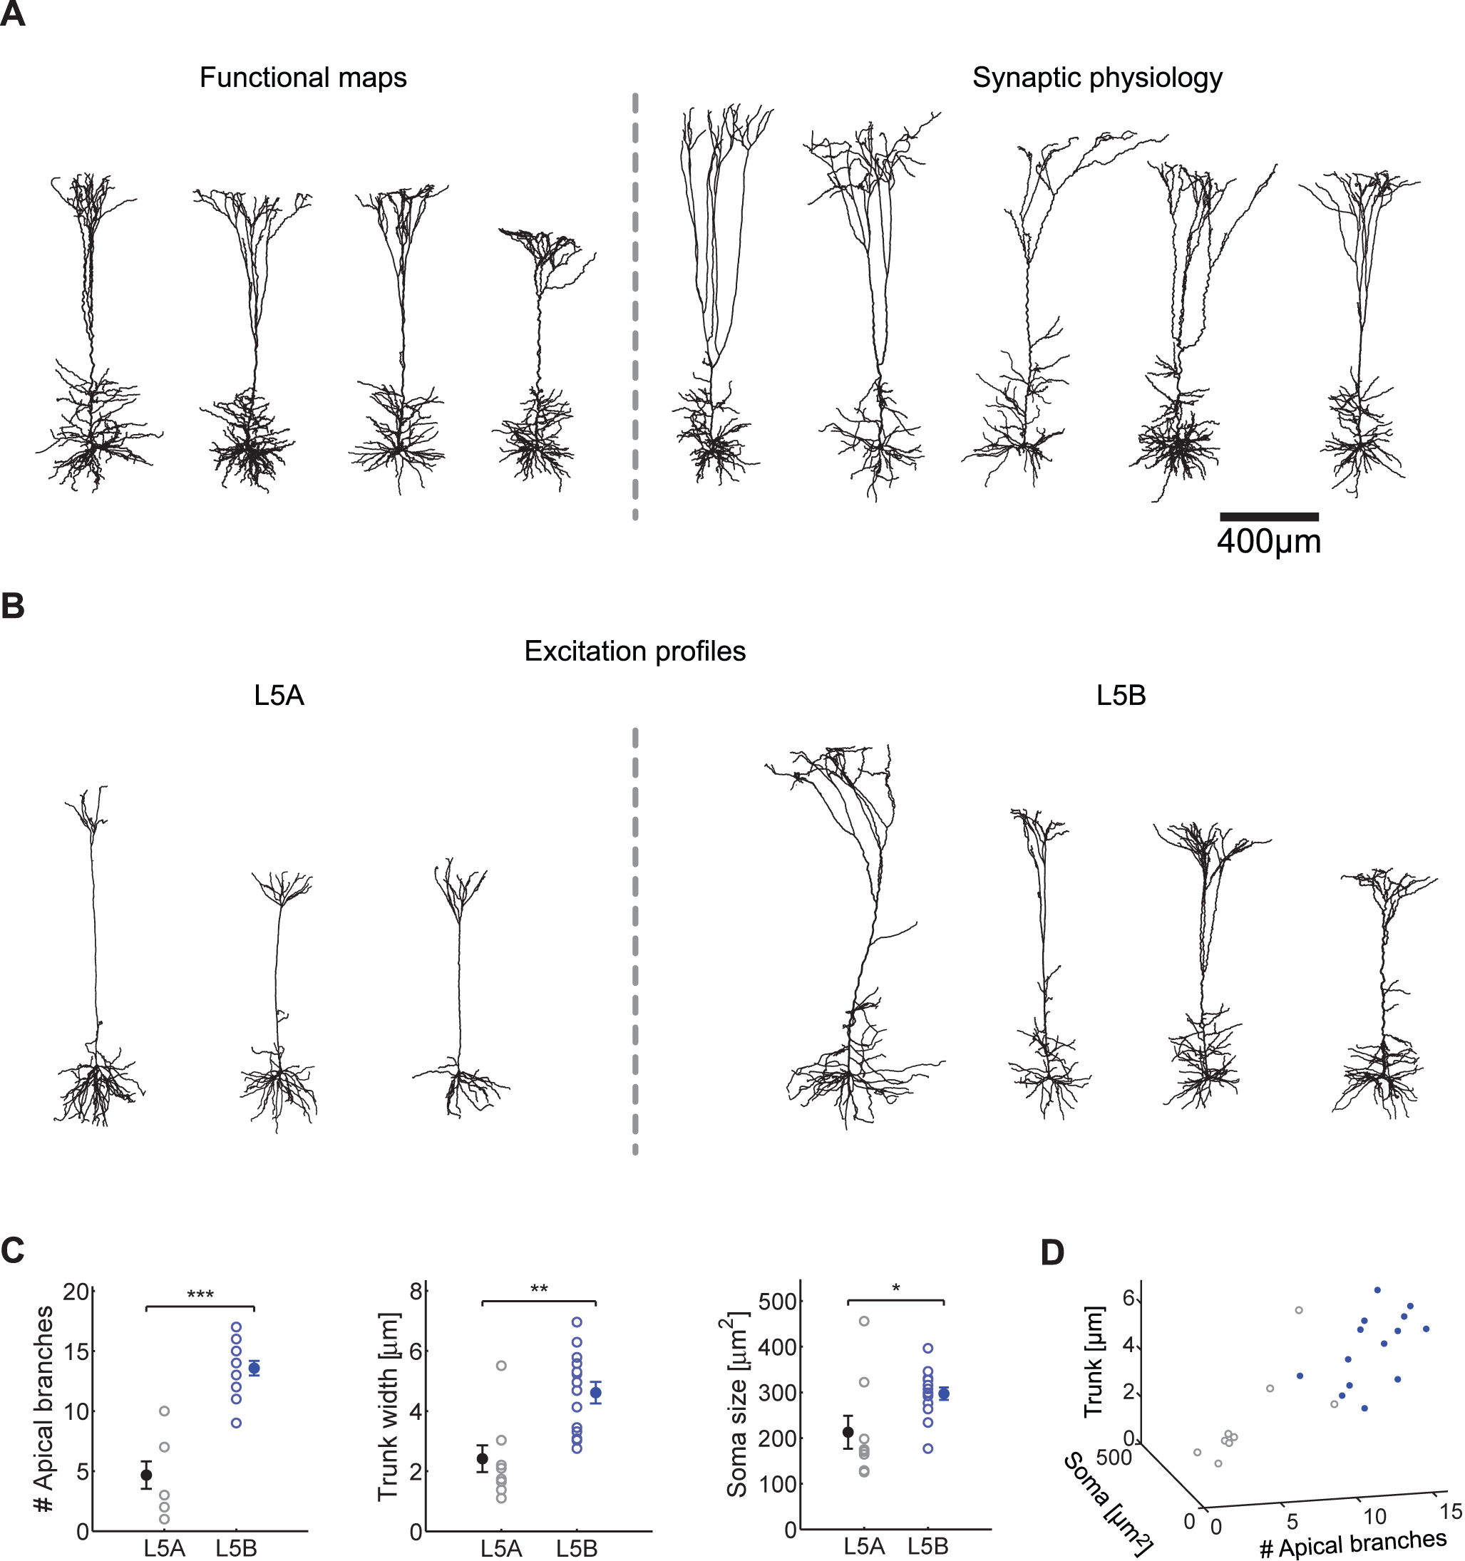
Figure S2: (A) Example reconstructions of the excitatory neurons tested in the calibration experiments in Figure 1. For simplicity, reconstructions were aligned to the pial surface and the size was minimally adjusted such that the somata of the neurons rest in the middle of the respective layer. (B) Normalization for cortical depth and curvature. In order to pool data from all experiments, the spatial positions of each uncaging location had to be normalized for cortical depth and curvature. First, the normalized vertical position of each location (pre, X₀) in a given layer was determined by minimizing the distance between the two opposing borders (2nd-order polynomial fits). Then, a trajectory of the original position was created in step-wise fashion until the somato-dendritic axis of the postsynaptic neuron was reached (grey dashed line, estimated by minimizing the distance between the measured position of the postsynaptic soma and the pial surface, assuming a radial orientation of the dendritic tree). As illustrated in step 1, the x-coordinates were moved horizontally (grey horizontal line), yielding a temporary coordinate X_{1’} and the vertical distance minimization procedure was repeated. Then, the y-coordinates were corrected to the original normalized y-distance by moving X_{1’} along the axis of the new shortest distance (grey vertical line) to yield new coordinates X₂. By repeating this procedure until the somato-dendritic axis was reached and integrating along the absolute distances of X_{1-n}, an estimation of the horizontal distance for the subsequent analysis was calculated. For the estimation of layer thickness, the mean absolute distance between the opposing borders from each step was used.
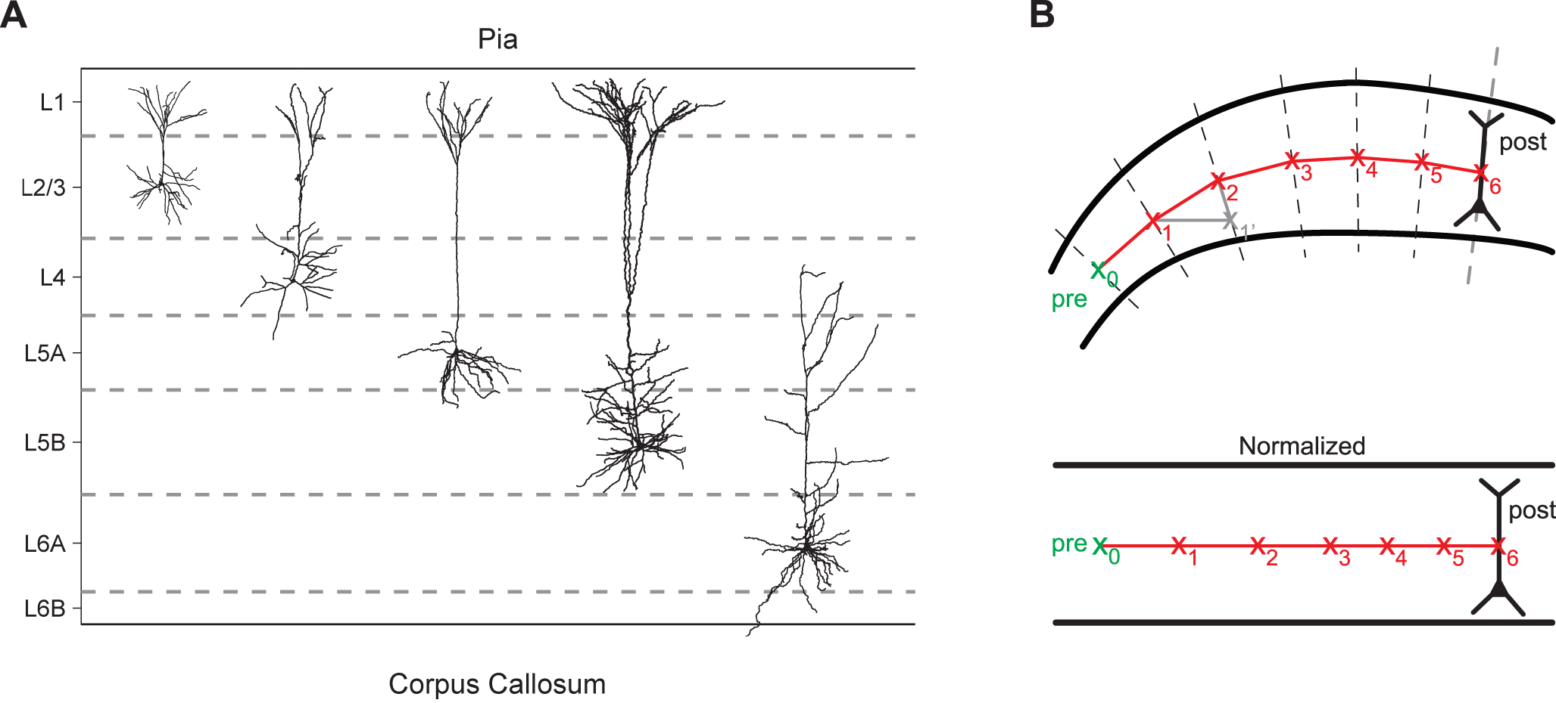
Figure S3: (A) L6 neurons show the highest average resistance across layers which could be one reason for their increased excitability during uncaging experiments. (B) Resting membrane potential (RMP) before caged-glutamate wash-in (left) and at the end of the experiment (right) for all cells recorded in excitation profile experiments shows no significant change due to the caged compound. (C) Linear dependence of laser power (LP) and pulse duration (PD) during uncaging experiments. Membrane potential deflections for different combinations of LP (grey color code) and PD (x-axis) show a linear relationship, the instance of supra-threshold stimulation resulting in an AP is marked with a red circle. We used these data to normalize the stimulation strength in the few instances where LP values up to 35mW were used to drive presynaptic neurons to elicit APs. (D) Peak time relative to stimulation onset of the first AP from calibration experiments with and without D-AP5. Even without the generation of bursts, the rise in excitability without D-AP5 is already apparent as AP-latency significantly decreased with consecutive trials (p<0.05). For this reason, we refrained from generating average EPSPs in our synaptic physiology experiments since the temporal jitter was not constant. (E) Slightly stronger stimulation of presynaptic cells does not decrease the spatial resolution of photostimulation. In some functional mapping experiments, the stimulation strength was increased (black symbols; mean PD: 6.9ms) to account for slight differences in slice-excitability and ensure presynaptic AP-generation. Compared to the normal stimulation strength (grey symbols; mean PD: 5.5ms) as derived from the calibration experiments, only the number of APs is increased while the spatial resolution of uncaging is unchanged. Data are pooled over cells from all layers (n=7).
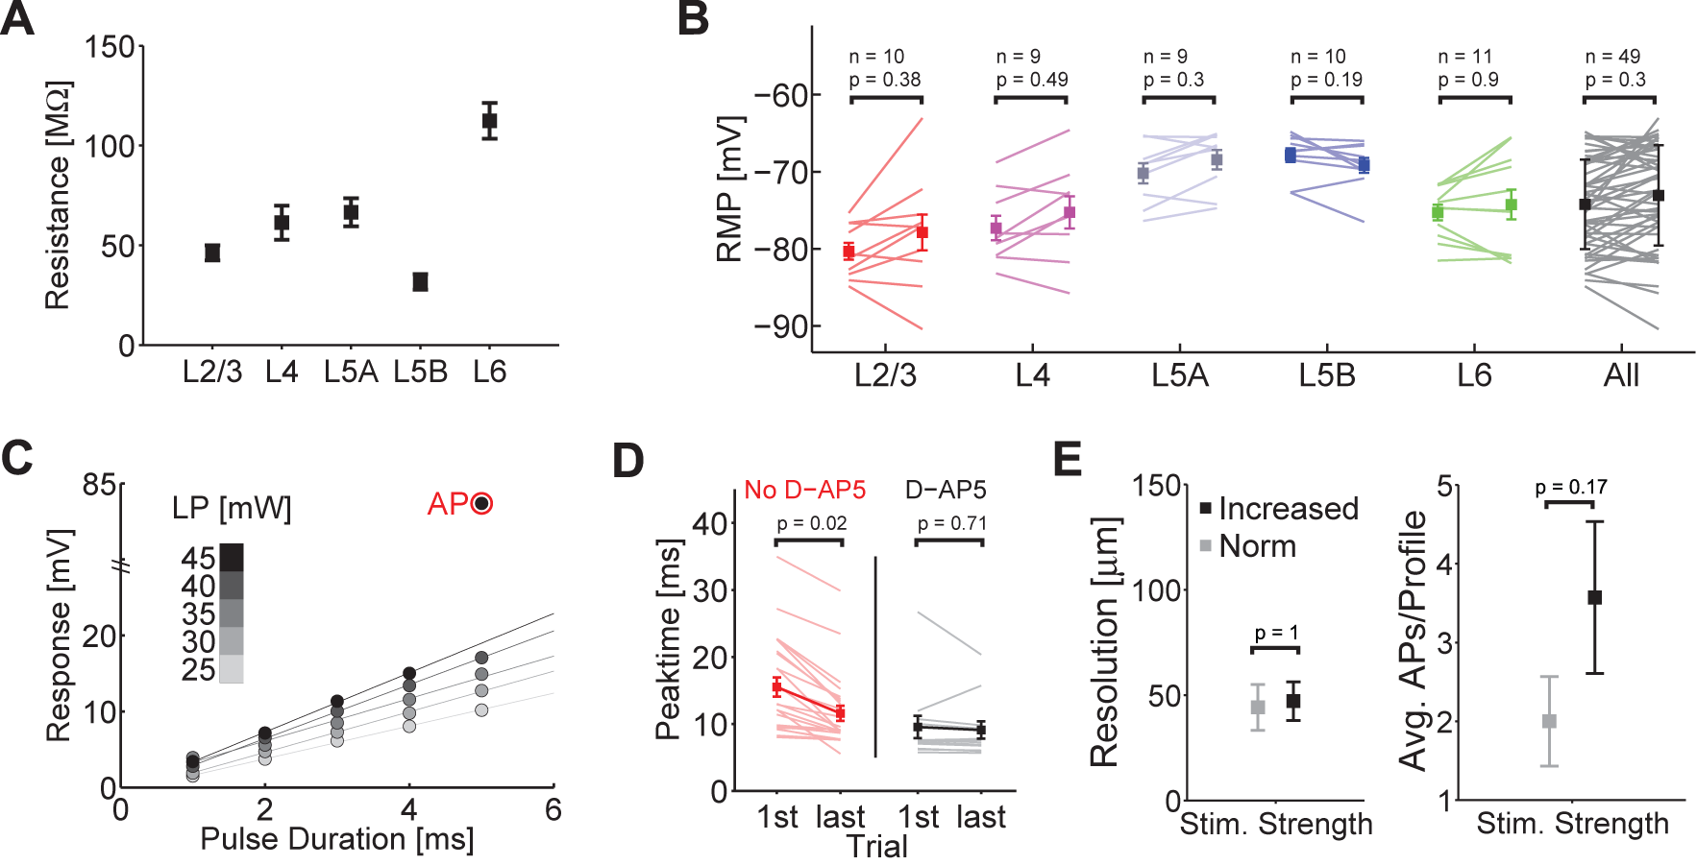
Figure S4: (A) Example excitation profile of a L5B neuron (soma: black triangle) including the distal dendritic region of the cell. The pixel values code for the peak membrane potential deflection in a 50ms time window after stimulation. Black pixels denote sites of AP-generation upon stimulation. Stimulation of the distal tuft does not drive APs in the soma. (B) Same as in (A) but for an example L2/3 neuron. AP-generation is limited to the perisomatic region of the cell. Scale bar in A applies. (C) Response amplitude upon stimulation of the soma (triangles) versus the tuft (Y, main bifurcation of the apical dendrite as visualized with Alexa488 (Tocris) during the experiment) of L2/3 (red, n=2) and L5B neurons (blue, n=3) shows that even very strong stimulation of the distal dendrite does not lead to AP-generation at the soma (LP was fixed to 25mW).
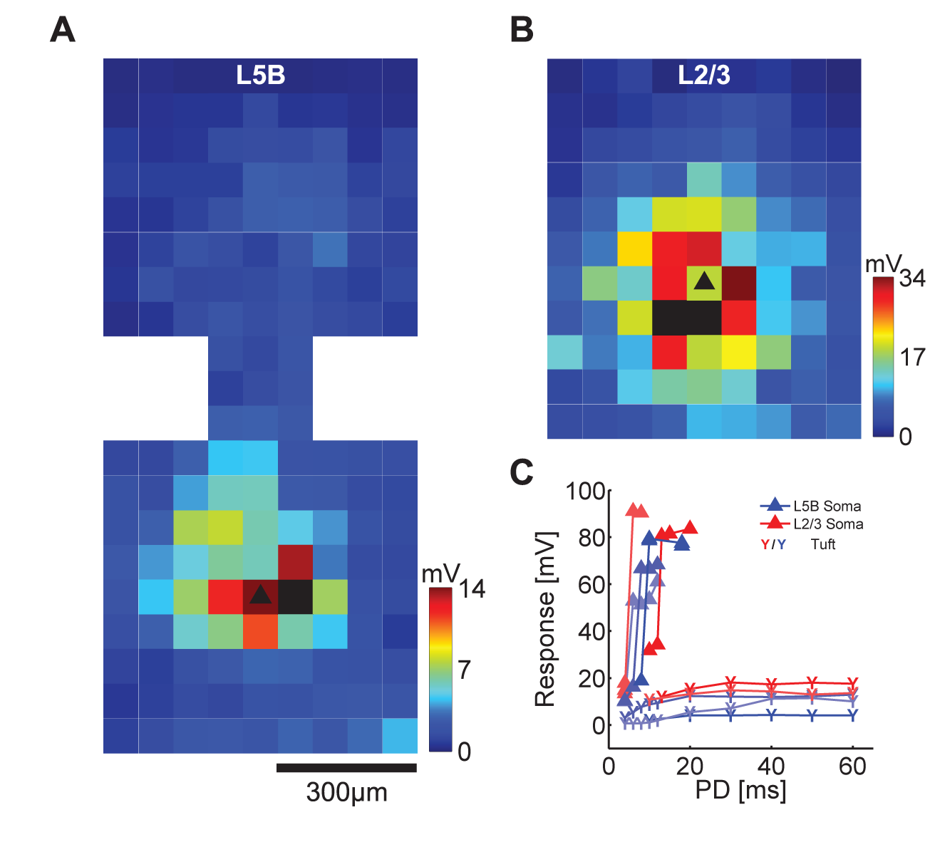
Figure S5: (A) Amplitude CV from n=449 projections. The last panel (black) contains the pooled data from all layers with fits from all layers superimposed. Except for L6, there is no significant change of CV with distance (black empty squares, mean ± SD of CV; grey squares were not used for fitting; bin size: 100µm). (B) Physiological parameters are stable over trials. The mean values (black; grey lines: single connections) of the first/second half of trials for the amplitude, rise-time and latency are not significantly different (subset of the data with 10 successful trials was used, n=48). (C) Examples of single amplitude measurements over 10 consecutive trials. Red lines show multilinear regressions (p-values denote significance versus slope=0). (D) Root-mean-square error (RMSE) as a goodness-of-fit measure for all tested connections. The majority of connections is stable over trials (p-value for significance versus slope=0 is color-coded, open symbols: p<0.05, grey circles denote connections shown in C).
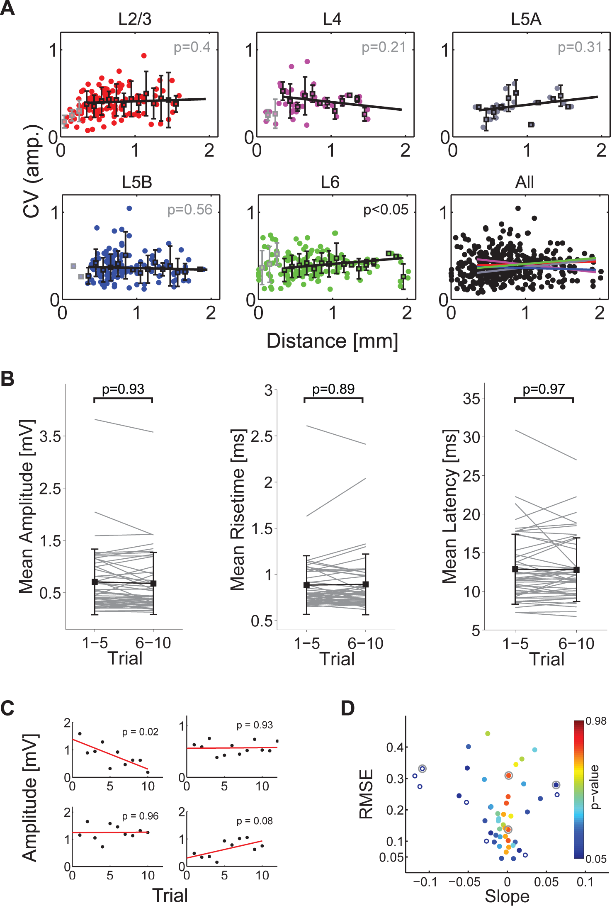
Figure S6: (A) Normalized spatial distribution of all stimulated projections (n=1,339) from 24 experiments in Figure 3. Filled circles indicate projections included in the analysis (n=449) while pale, open circles denote projections which could not be analyzed according to our criteria (see Methods). (B) Onset latency of EPSPs versus horizontal distance to the postsynaptic neuron from all projections. The red line denotes a multilinear regression with a slope of r = 1.64ms/mm (p<0.01). This reflects the increase in axonal delay with increasing distance, which fits well with the observed axonal delays of unmyelinated axons (~1-2ms/mm). (C) Distribution of AP-latencies to stimulation onset, showing that the long latencies of recorded EPSPs are largely due to the uncaging time course and presynaptic spike formation (cf. Nawrot et al. 2009).
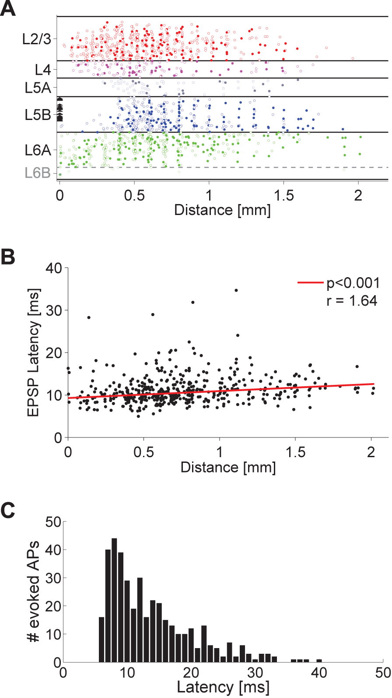
Figure S7: Functional maps from n=3 cells in coronal slices, overlaid on the brightfield image taken during the experiment. The general projection pattern is comparable to the experiments in parasagittal slices (most projections originate in L2/3 as well as L5B/L6), supporting the assumption of isotropy of connectivity on the spatial scale investigated in our study (Fig. 4). Response strength is color-coded, white circles denote the position of the soma of the L5B-pyr.
